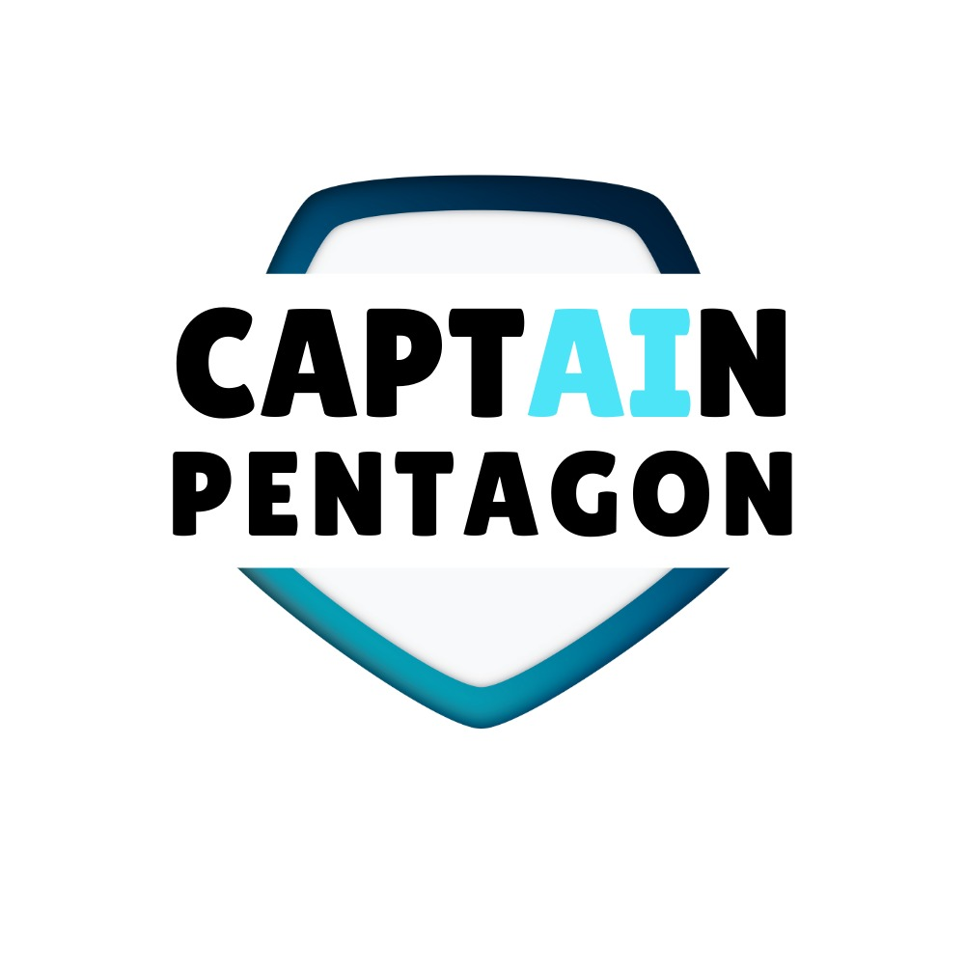

CAPTAIN PENTAGON PROJECT DOCUMENTATION

ANDROID MALWARE DETECTION APP

PREPARED BY:

CAPTAIN PENTAGON TEAM

**CONTENTS**

Contents

1. INTRODUCTION 3

1.1 Purpose 3

1.2 Scope 3

2. DESIGN CONSIDERATIONS 4

2.1 Assumptions 4

2.2 System Environment 4

3. UI/UX Design 5

3.1 Splash screen 5

3.2 User set up page 7

3.3 Home Main Page 8

3.4 AI ChatBot 9

3. 4.2 AI Chat page 10

3.5 Malware Scanning page 11

3.5.2 Malware scanning result page 12

3.6 Quiz page 13

Testing Plan 17

# PROJECT TITLE

The project title is **CAPTAIN PENTAGON**. The purpose of this project is to design an AI Malware Detection apps.

**CAPTAIN** represents strength, speed, agility that stands up for people and **PENTAGON** represents a powerful defensive shield against cybercrimes.

The project team are from Diploma in Computer Science Programme. The project teams members are:

Teow Chee Wen - Project Manager and Backend Developer (Malware Scan module)

Jack Liew Wern Bing - Frontend Developer (Quiz module)

Siow Wei Qi - Frontend Developer (Quiz module)

Siow Wei Qun - Frontend Developer (AI Chatbot module)

Lee Wen Keat - Backend Developer

# PROJECT GOAL

Users are at serious danger from the growing threat of malware on Android smartphones, which can lead to privacy invasion, data theft, and poor device performance.

Many of the malware detection apps available today are either too complex for students’ group or doesn't have sufficient features to educate them while keeping their system protected.

The goal of this project to design a user-friendly AI malware detection mobile apps that has a simplified design and yet interactive for the users.

Therefore, a tailor-made apps is needed to capture the student market.

# TARGET AUDIENCE

This system is designed especially for students’ groups who is between 12 – 20 years old.

# APPS INTRODUCTION

“CAPTAIN PENTAGON” is a user-friendly AI malware detection mobile apps designed with simplified concept specially targeted to students’ group.

The Unique Value Propositions (UVP) are AI Integration and Gamified Learning Experience. Users can execute the Malware Scanning and take advantage of the Gamified Learning Experience to enhance their cyber security knowledge.

**GAMIFIED LEARNING EXPERIENCE**

Quiz is incorporated for users to evaluate their cyber security knowledge and continuously enhance their knowledge from beginner to advance level.  The motive of this Gamified Learning Experience is to transform the users to be knowledge users while being digitally connected.

**AI INTEGRATION**

AI enhances the malware detection accuracy by incorporating Machine Learning (ML) to analyse and predict Apps Permissions in Android Platform.

AI ChatBot is integrated to provide a greater engagement for users to connect with the apps. Users can interact with Mr. Bot to learn about Malware and Cybersecurity during the interval of the scanning period.

# PROJECT SCOPE

**Malware Detection**:

* Scanning and identifying various types of malwares including viruses, trojans, spyware, adware, ransomware, and more.
* Real-time monitoring to detect suspicious activities and potential threats as they occur.

**Security Features**:

* Regular updates to the malware database to ensure the latest threats are detected.
* Integration of advanced security protocols to protect against phishing, malicious websites, and unauthorized access.

**User Interface**:

* A user-friendly interface that allows easy navigation and understanding of the app’s features.
* Detailed reports and notifications about scan results, detected threats, and security status.

**Performance Optimization**:

* Ensuring minimal impact on device performance during scans
* Options for scheduled scans to run at convenient times for the user.

**Data Privacy and Security**:

* Strict adherence to data privacy regulations and best practices to ensure user data is not compromised.
* Encryption of sensitive information and secure handling of detected threats.

# PROJECT REQUIREMENTS

This project adheres to the requirements specified by ANCC 2024 Team.

Java and XML Programming were used as the Android Native for Front End Development. Python and Machine Learning were used for the Back End Development. AI and education games were included as part of the Innovation and Creativity. Functionality: The solution should effectively identify and alert users about potential threats.

The apps safeguards user data and privacy, complying with industry standards such as Open Web Application Security Project (OWASP). Testing was done with the condition of handling edge cases too.

# 7. TECHNICAL SPECIFICAL

## 7.1 Assumptions

This apps runs smoothly on android application and suitable for mobile devices owned by students’ group

## 7.2 System Environment

The apps were solely developed using Android studio and GitHub. The system was developed with Java programming, XML, Python and Machine Leaning. The apps complies to the concerns specified by Open Web Application Security Project.

# 8. UI/UX Design

|  |  |
| --- | --- |
| 8.1 Splash screen | 8.2 User set up page |
|  |  |
| 8.1.1 Splash screen diagram  When the users click the CAPTION PENTAGON apps, the above Splash screen will be displayed. | 8.2.1 Diagram User set up page  Users enter their name and choose their knowledge level in Cybersecurity. |

|  |  |
| --- | --- |
| 8.3 Home Main Page | 8.4 AI ChatBot |
|  |  |
| 8.4.1 Home Main Page Diagram  When the user key in their information, will go true our home main page. There is Malware scan, AI chat, Quizzes and news. | 8.4.2 AI ChatBot Diagram  When the user clicks the AI Chat icon, will display this splash screen page. |

|  |  |
| --- | --- |
| 8.5 AI Chat page | 8.6 Malware Scanning page |
|  |  |
| 8.5.1 AI Chat Page Diagram  The AI chat bot the user can ask any questions, the Mr. Bot will be answering your question.  . | 8.6.1 Malware scanning page Diagram  When the user clicks the Malware Scan icon, the apps perform the scanning of malwares. |

|  |  |
| --- | --- |
| 8.7 AI Chat page | 8.8 Quiz page |
|  |  |
| 8.7.1 Malware scanning result page diagram  When scanning completes, the scanning status is displayed along with list of malwares if detected. Users can click on the Delete button, to delete all the malwares. Upon deleting, the apps confirms that the device is safe for use now.  . | 8.8.1 Quiz Splash Screen diagram  When the user clicks on the Quiz icon, Users can begin the quiz. |

|  |  |
| --- | --- |
| 8.9 AI Quiz Level page | 8.10 Quiz page |
|  |  |
| 8.9.1 Quiz Level page Diagram  Users can choose quiz difficulty level.  . | 8.10.1 Quiz question and answer page Diagram  When the user selects the difficulty of quiz will display question to let the user answer. |

.

|  |  |
| --- | --- |
| 8.11 AI Quiz Result page |  |
|  |  |
| 8.11.1 Quiz result page Diagram  After answering all questions will display your score. |  |

# 9 Testing Plan

The Testing Case below was prepared to test the functionalities and User Acceptance Test. The test includes the evaluation criteria for the apps as well. The testing was carried out among the students’ group.

5 students were invited to test the apps. Students showed excitement in using the Gamified Learning Experience through quiz and the Chatbot integration. Students felt comfortable with the flow and the features of the apps. The feedback received from students confirms that this apps is suitable for students’ group.

However, some important feedbacks were noted, and improvement were made to the apps. The feedbacks were as follows:

* Quiz Levels – improve to Beginner-Int – Advance.
* Allow users to delete the malware and confirms the device is safe to use.
* Validation included for Name column.
* Improve positioning of scanning result page.
* Music played during the quiz must end when quiz ends.

All improvement were made after the Testing Case.

| **CAPTAIN PENTAGON Testing Case Checklist** | | | | | | |
| --- | --- | --- | --- | --- | --- | --- |
| Tested By |  | | | | Date |  |
| Application Name |  | | | | | |
| Procedure | | Expected Result | Pass/Fail  (P/F) | Actual Results/Comments | | |
| Functionality | | | | | | |
| Perform Scan and Identify Malware | |  |  |  | | |
| Display Scan Result and alert users about potential threats. | |  |  |  | | |
| Run all level of Quiz and present the outcome | |  |  |  | | |
| Able to obtain relevant respond from AI ChatBot | |  |  |  | | |
| User Experience | | | | | | |
| **Application is Intuitive** – able to suggest list of questions User may ask the AI Chatbot instead of typing | |  |  |  | | |
| **Application is Intuitive** – the system is designed to provide learning experience while scanning is in progress | |  |  |  | | |
| **Application is Responsive** – able to display the apps screens using inline style, different layouts, to ensure consistent UX | |  |  |  | | |
| Ease of Use – all screen flow is simplified and easy to use | |  |  |  | | |
| Basic Application Testing | | | | | | |
| Performs as expected when other applications are open | |  |  |  | | |
| Easy to navigate from one screen to the other.  Example:   * From ChatBot to Main Page * From Quiz to Main Page * From Scanning/ Scan Completed to Main Page | |  |  |  | | |
| Scan Screen displays details sufficiently | |  |  |  | | |
| Result Page provides the status of the scan | |  |  |  | | |
| Result Page alert users about potential threats. | |  |  |  | | |
| User can exit from the Result page. | |  |  |  | | |
| Quiz page - User can exit from Quiz main page and move from any Quiz page to Main Page anytime. | |  |  |  | | |
| Quiz page display one quiz at time at completes 10 questions for each level. | |  |  |  | | |
| Quiz Page – result page is displayed with score. | |  |  |  | | |
| Scalability Testing | | | | | | |
| Application is modular – Scanning / ChatBot / Quiz are independent module | |  |  |  | | |
| Application is scalable, and capable of handling new malware set. | |  |  |  | | |
| Edge Case Testing | | | | | | |
| Can Handle wrong Input (Numbers or Special Character) in Name textbox | |  |  |  | | |
| Can handle Input less relevant question in Chatbot - out of cyber security scope. | |  |  |  | | |

# 10 Conclusion

The project was completed successfully by the CAPTAIN PENTAGON team. The apps designed meets the project Goal. The apps is simplified a user-friendly AI malware detection mobile apps with interactive and engagement experience for student group.

-THANK YOU-